Kolavo V1 Testing

To revise

M1 - Build public community list 🧾
No. | What is wrong? | How should it be?
1 | 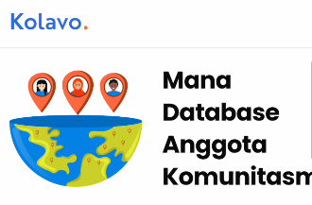  Copy did not show full on mobile screen | - Update to WAG
2 | It will be less on pc | - Separate it in two lines  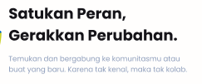
3 | The subheading content won’t align with the new heading content. | - Change to  Temukan dan bergabung ke komunitasmu atau buat yang baru. It is time to connect, collaborate, and create more impact.
4 |   On mobile version, nav bar only visible when scrolling down | - It needs to stay visible to mimic mobile app experience
5 | 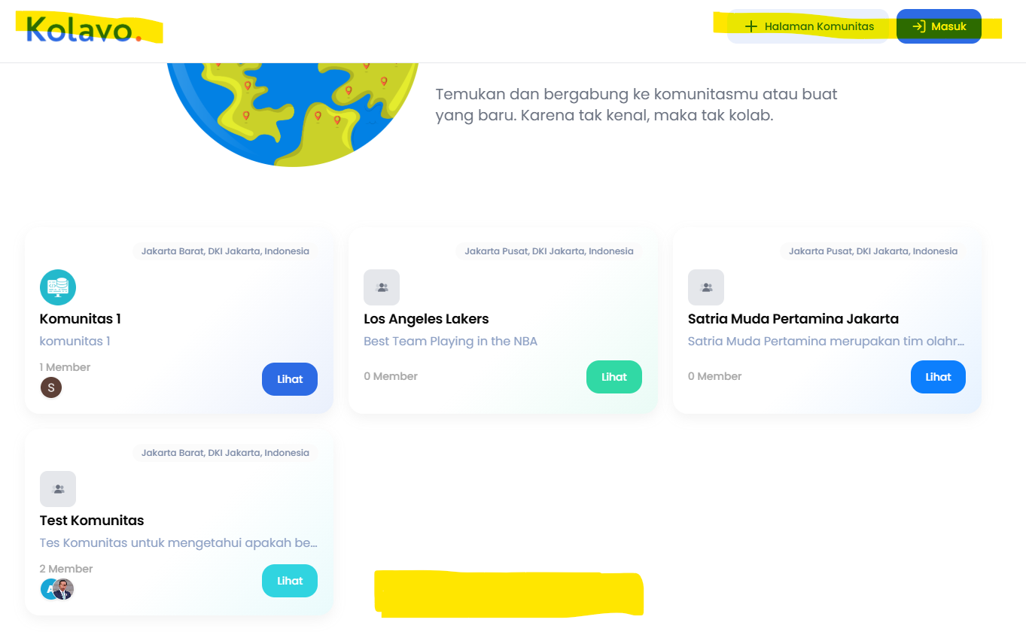  Header stays visible with no navbar | - When scrolling down:  - Hide header  - Show nav bar  On pc version, the nav bar needs to be visible when scrolling down while header is invisible, to make user focus on community instead of Kolavo.  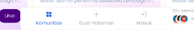  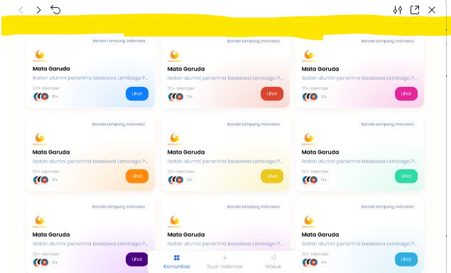
6 | 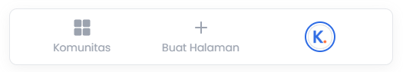  Nav bar stays visible in all pages making it redundant with header | - On PC, when scrolling down:  - Hide header  - Show nav bar

M1 - Build admin community profile
No. | What is wrong? | How should it be?
1 | 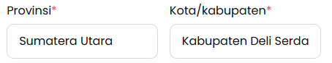  Province and cities are required | - Let it not required so communities who don’t have physical base camp or cover only province level can be related
2 | 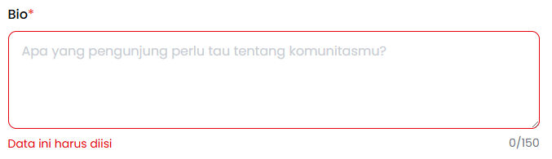  Bio is required | - Let it not required so users can take time to think the align sentence to their communities
3 | 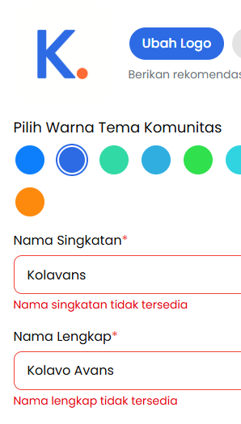  When editing profile, suddenly both abbreviation and full names are not available without changing it | - Should not happen

M3 - Build Public Community Member Distribution
No. | What is wrong? | How should it be?
1 | 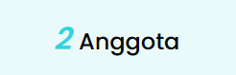  Unclickable | - Clickable with 3 conditions:  - Not logged in: login modal  - Logged in but not member: registration form  - Logged in and member: directs list of member page  - Logged in but rejected: unclickable
2 | 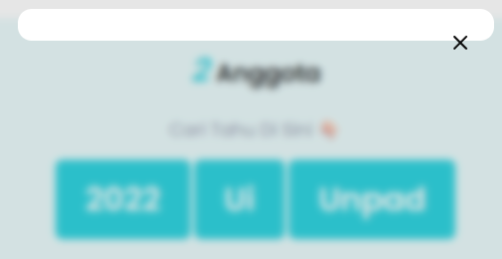  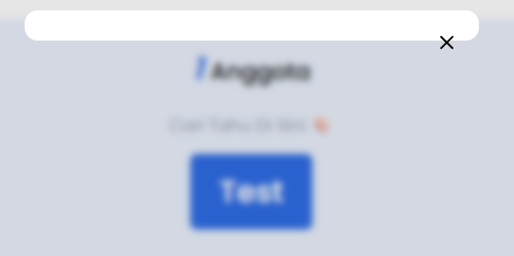  Member distribution did not show properly to not logged in user | - Show member distribution to all type users
3 | 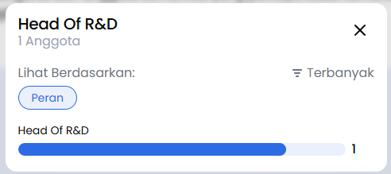  Not all chips shown | - All chips to be shown and can be clicked which will change the member distribution

M1 - Build public community profile 🪞
No. | What is wrong? | How should it be?
1 |   Logo not shown to other than admin. | - Uploaded logo to be shown to all users
2

M2 - Build User Profile Display & Community List
No. | What is wrong? | How should it be?
1 | 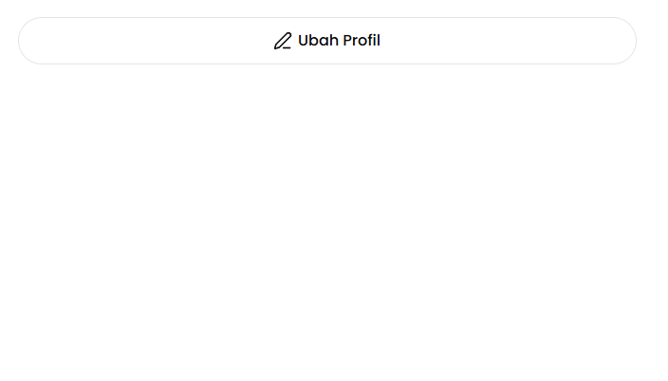  There is no empty state of community lists when user not updated profile yet | 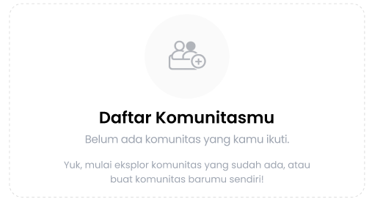  - There is empty state to make user aware of this place
2 | 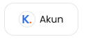  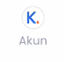  ‘Akun’ is visible after updating profile | - Only profile picture shown, no word  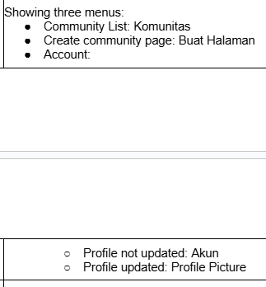
3 |   Admin icon is a king crown | - Admin icon is a cup of coffee  
 |   Member icon is diamond and the color is grey | - Member icon is an ice cream and blue Kolavo color
 | Member icon looks different on user profile triggering from community member | - All should look the same  - Ice cream and blue Kolavo color

M3 - Build Admin Community Membership Setup
No. | What is wrong? | How should it be?
1 | 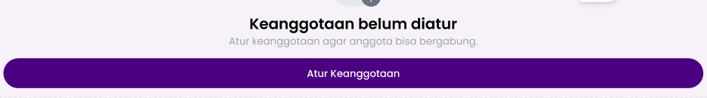  This doesn’t look balanced | - Resize to Gabung button size  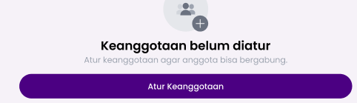
2 | 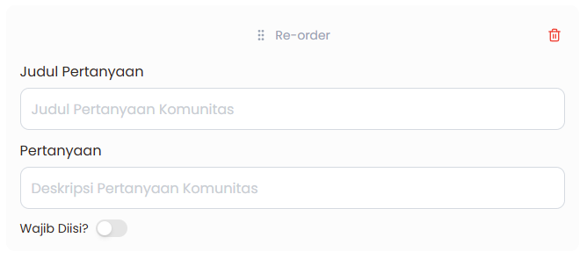  No question limit | - Admin can only add up to 5 questions
3 | 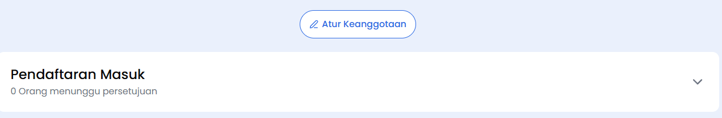  Atur keanggotaan button and incoming applicants once membership set up don’t look balance | - Resize to Gabung button size  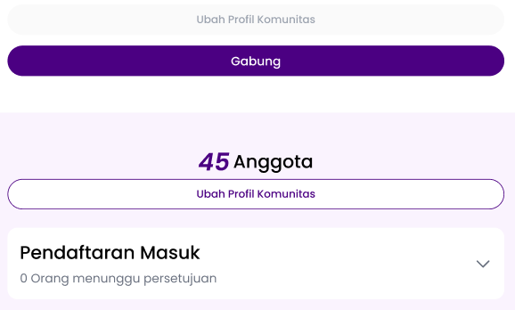

M3 - Build Admin Joining To Community As Member
No. | What is wrong? | How should it be?
1 | 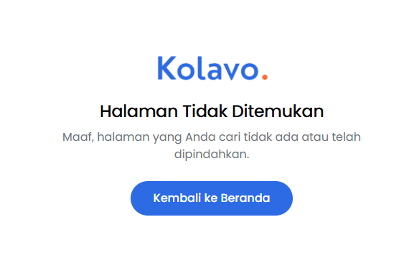  Page not found when admin wants to join as member | - Admins can access the registration form and register for membership so their data is counted as well.

M4 - Build Community Member Discovery for Member
No. | What is wrong? | How should it be?
1 | 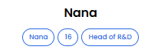  User nickname becomes tag | - User nick name and member ID not to be tag  - Only answers of maximum 5 new questions become tags
2 | Tag is not clickable | - Tag is clickable and auto activate chips and filter  For example, clicking Tag 16 activates chips Jumlah Komunitas and filter 16.  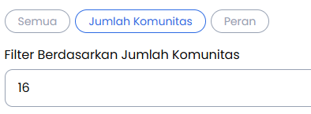
3 | 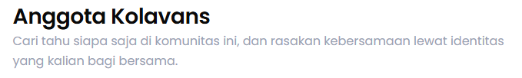  Copy won’t align to the new homepage heading and subheading | - Change to:  Lihat siapa saja di komunitasmu. Kenali kekuatan setiap peran, dan bersiaplah untuk bergerak menciptakan dampak bersama.

Additional
No. | What is wrong? | How should it be?
1 | Favicon is vercel’s | - Kolavo icon, it is uploaded here 01 EPIC - Public Community Discovery or here is one without background 01 EPIC - Public Community Discovery

M3 - Build Membership Application and Approval
No. | What is wrong? | How should it be?
1 | 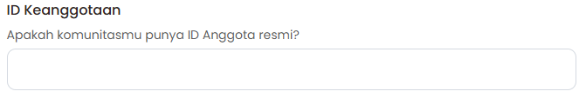  The question is supposed to be for admin | - Question title: Nomor Keanggotaan  - Description: Isi nomor keanggotaan jika ada

